**-- Students Table**

INSERT INTO students (enrolment_no, faculty_no, name, dob, hostel_name) VALUES

('GL5698', '24CSEUG101', 'Ali Raza', '2001-02-15', 'Sir Syed Hostel'),

('GL5699', '24MBBSU103', 'Fatima Noor', '2002-07-10', 'Begum Rokeya Hostel'),

('GL5700', '24BATEC105', 'Zoya Khan', '2002-05-01', 'Indira Gandhi Hostel'),

('GL5701', '24LLMGR202', 'Yusuf Hamid', '2001-11-23', 'Sir Syed Hostel'),

('GL5702', '24BAHIS107', 'Sameer Javed', '2000-09-12', 'Aftab Hostel'),

('GL5703', '24BTECH208', 'Sana Tariq', '2001-03-18', 'Begum Rokeya Hostel'),

('GL5704', '24MCAIT301', 'Nasir Ali', '2000-12-20', 'Sir Syed Hostel'),

('GL5705', '24MBAHR303', 'Hina Qureshi', '2001-06-15', 'Indira Gandhi Hostel'),

('GL5706', '24BSCBZ112', 'Talha Syed', '2002-01-11', 'Zakir Hussain Hostel'),

('GL5707', '24BCOMFN211', 'Uzma Khatoon', '2001-10-19', 'Begum Rokeya Hostel'),

('GL5708', '24MTECHCE401', 'Adnan Farooq', '2000-07-25', 'Aftab Hostel'),

('GL5709', '24PHDLAW501', 'Shaista Rehman', '1998-04-12', 'Begum Rokeya Hostel'),

('GL5710', '24LLBUG603', 'Tariq Zaman', '2002-03-05', 'Sir Syed Hostel'),

('GL5711', '24BBAFN701', 'Hiba Anwar', '2001-09-08', 'Indira Gandhi Hostel'),

('GL5712', '24BTECHME801', 'Saif Uddin', '2000-02-22', 'Zakir Hussain Hostel'),

('GL5713', '24BCSEDS103', 'Arsalan Mehmood', '2002-12-30', 'Sir Syed Hostel'),

('GL5714', '24MAECON901', 'Noor Fatima', '2001-05-17', 'Begum Rokeya Hostel'),

('GL5715', '24BSWSP708', 'Farhan Raza', '2002-08-14', 'Aftab Hostel'),

('GL5716', '24BAENG204', 'Rehana Bano', '2000-11-02', 'Begum Rokeya Hostel'),

('GL5717', '24BSCMAT301', 'Junaid Akhtar', '2001-01-09', 'Sir Syed Hostel');

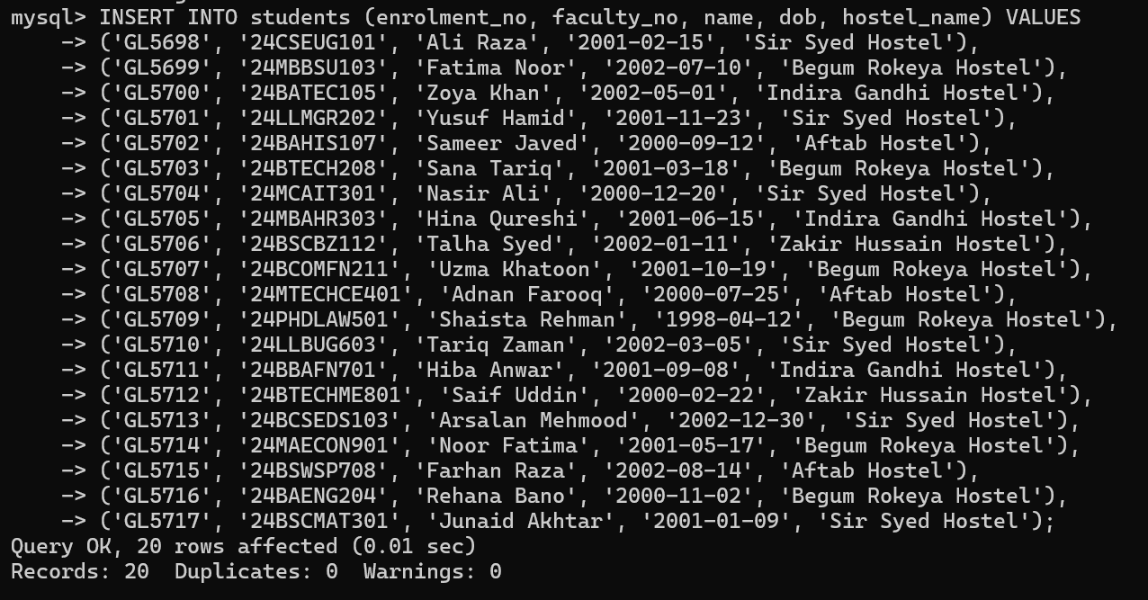

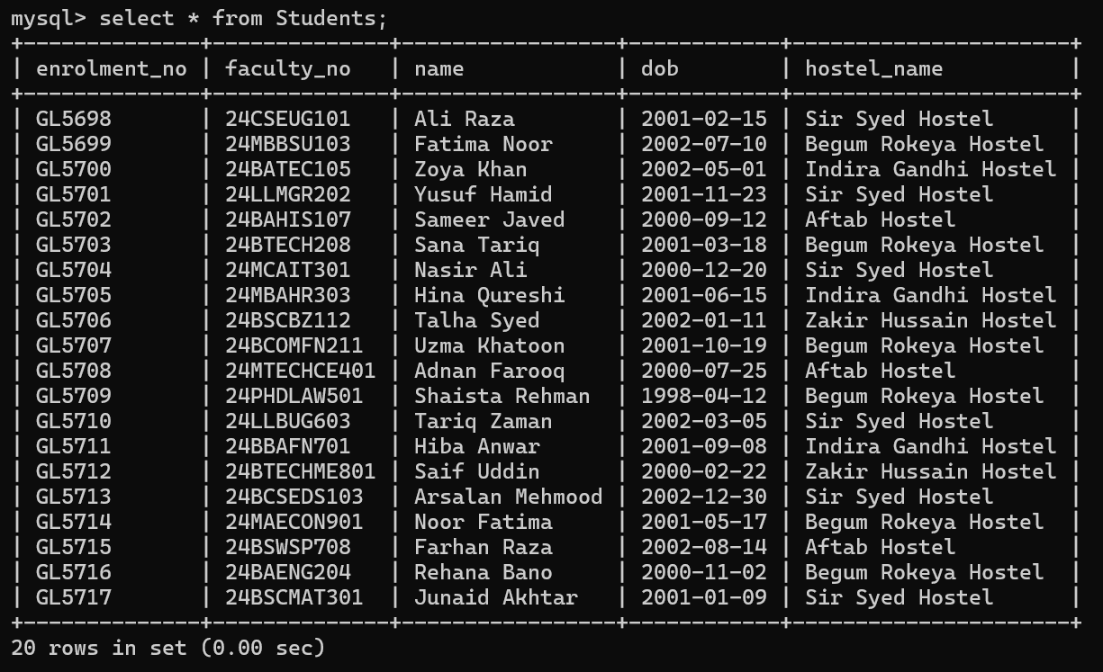

**-- Vendors Table (only one vendor)**

INSERT INTO vendors (username, password) VALUES

('admin', 'admin123');

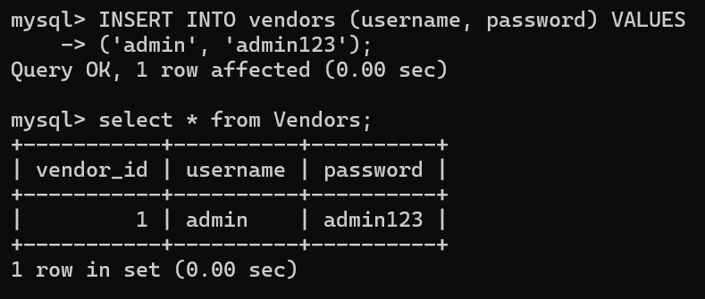

**-- Meals Table**

INSERT INTO meals (vendor_id, meal_name, meal_type) VALUES

(1, 'Poha, Tea, Banana', 'Breakfast'),

(1, 'Bread, Butter, Boiled Egg', 'Breakfast'),

(1, 'Aloo Paratha, Curd', 'Breakfast'),

(1, 'Rice, Daal, Roti', 'Lunch'),

(1, 'Rajma Chawal, Salad', 'Lunch'),

(1, 'Biryani, Raita, Papad', 'Lunch'),

(1, 'Pulao, Raita, Kheer', 'Dinner'),

(1, 'Chapati, Mix Veg, Dal Fry', 'Dinner'),

(1, 'Chicken Korma, Rice, Pudding', 'Dinner');

